**Solution:**

**Dataset Used:** ecommerce_data.csv uploaded in my github

**Total Sales by Region: Use of SELECT**

**Use of SELECT sub-category**

**Use WHERE, ORDER BY, GROUP BY**

1. **Find total sales by Category (Group by Category, filter by Sales > 1000 and order by Sales descending)**:

1. **Filter orders with a specific shipping mode, order by Order Date**:

**Use JOINS (INNER, LEFT, RIGHT)**

**INNER JOIN (Comparing two orders from the same customer):**

**LEFT JOIN** (Show all orders, including those without a match from the same customer):

**RIGHT JOIN** (Show orders even if there’s no previous order by the same customer):

**2. Write Subqueries**

**Find orders with sales greater than the average sales:**

**3. Use Aggregate Functions (SUM, AVG)**

**Total sales by Ship Mode:**

**Average profit by Category:**

**4. Create Views for Analysis**

**Create a view to show high-value orders (Sales > 100):**

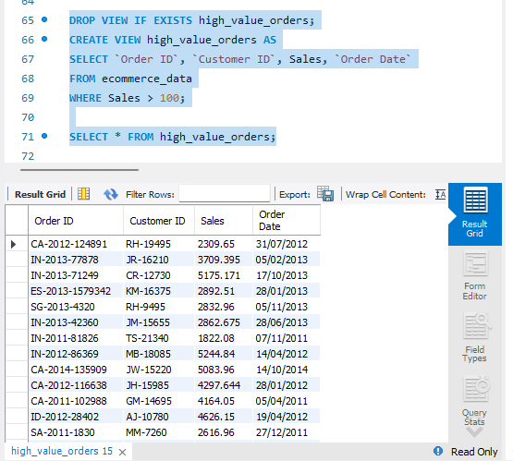

**5. Optimize Queries with Indexes**

**Create an index on Customer ID for faster lookups:**

